TPS I-VI Deepa Map

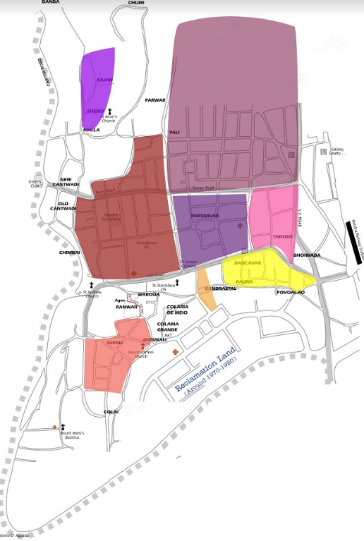

IS TPS VI inb the correct place ? Correlate with Gazdar Estate/Band